**Network Design Proposal for Apollo Business Consulting**

**Group 12**

**Prepared for Simon Galton**

**COMP 10019**

**Fall 2024**

**Table of Contents**

|  |  |  |
| --- | --- | --- |
| Section |  | Page Number |
| Introduction | . . . . . . . . . . . . . . . . . . . . | 3 |
| Executive Summary | . . . . . . . . . . . . . . . . . . . . | 4 |
| Business Profile | . . . . . . . . . . . . . . . . . . . . | 5 |
| Logical Network | . . . . . . . . . . . . . . . . . . . . | 6 - 10 |
| Physical Network | . . . . . . . . . . . . . . . . . . . . | 11 - 16 |
| Cabling | . . . . . . . . . . . . . . . . . . . . | 17 - 26 |
| Hardware | . . . . . . . . . . . . . . . . . . . . | 27 - 29 |
| Wireless Configuration | . . . . . . . . . . . . . . . . . . . . | 30 - 31 |
| Cost Estimates | . . . . . . . . . . . . . . . . . . . . | 32 |
| Conclusion | . . . . . . . . . . . . . . . . . . . . | 33 |
| Appendix A:  TIA/EIA Compliance | . . . . . . . . . . . . . . . . . . . . | 34 |
| Appendix B:  Current Floorplans | . . . . . . . . . . . . . . . . . . . . | 34 - 36 |
| Appendix C:  Subnetting | . . . . . . . . . . . . . . . . . . . . | 37 |
| Appendix D: Cisco Pricing | . . . . . . . . . . . . . . . . . . . . | 38 |

**Introduction**

The purpose of this document is to provide a thorough overview of SHANA Networks' proposed 3-tier network solution for Apollo Business Consulting's new 5 floor campus.

At every stage of our process, we have made design decisions with your future in mind. In the dialogue we've had with your representatives, and the supplementary research we've done into your enterprise, it has been made abundantly clear that our design needs to support the growth your company expects to see over the coming years. We at SHANA believe our design will provide you with a fast, robust, and scalable network that can act as a sturdy foundation the folks at Apollo Business Consulting can rely on for years to come.

This report will clarify the specifics of our design, rationalize those decisions in the context of your organization, and provide insight and thorough analysis where appropriate.

At a glance, this design will provide your campus with a suite of high-end Cisco switches including: 3x Catalyst 9300X (C9300X2-24Y), and a series of Cisco Business 350 switches in various sizes (8x CBS350-24FP-4X, 8x CBS350-48FP-4X, and 5x CBS350-8FP-E-2G). These switches will be interconnected by 345 meters of multi-mode fibre, and 13,483 meters of Category 6 cabling all of which comply with TIA/EIA 568 standards. Additionally, we have provided a Cisco FirePOWER 3140 Next Gen Firewall (FPR3140-NGFW-K9) to protect your network traffic and a Cisco Catalyst 9800 Wireless Controller (C9800-40-K9) which will serve to control the 5 preliminary access points (C9120AXI-EWC-A) we have opted to bundle with this network design.

We look forward to bringing this project to life and on behalf of the SHANA team:

*Thank you for the opportunity to provide this proposal.*

**Executive Summary**

This report provides a thorough overview of the 3-tiered network SHANA networks is proposing for Apollo Business Consulting's new 5 floor campus.

This design makes use of high-end, enterprise grade Cisco products including a Cisco FirePOWER 3140 Next Gen Firewall (FPR3140-NGFW-K9), three Cisco Catalyst 9300X switches (C9300X2-24Y) for both the core and distribution layers as well as a suite of Cisco Business 350 series switches (CBS350-24FP-4X (8x)) (CBS350-48FP-4X (8x)) which will provide access level connectivity. Additionally, our design provides a set of Cisco CBS350-8FP-E-2G (5x) switches which will allow for the implementation of an AP array after a thorough site survey is conducted. This hardware will be connected vertically by a 345 meter multi-mode fibre backbone and distributed to your employee workstations via 13,483 meters of Category 6 cabling all of which comply with TIA/EIA 568 standards.

This configuration will provide all 311 employees of Apollo Business Consulting and its president each with a 1 Gigabit connection to this network with significant room for growth.

Our team has calculated an initial acquisition estimate of **$ 531,639.35** with a yearly upkeep of **$ 34,992.57**.

This estimate includes a recommended annual allocation of approximately ~10% of the original hardware purchase price. This fee covers software licenses for network management features like Cisco Digital Network Architecture (DNA) as well as a subscription to Cisco’s SmartNet support service which provides access to technical support, software updates, and other maintenance features for the full lifecycle of these products.

**Business Profile**

Over its 15 year history, Apollo Business Consulting's commitment to corporate excellence has fuelled it's growth to an impressive 311 employees which span a hierarchy of 11 distinct departments.

This year marks a bold milestone for Apollo, as the company has opted to relocate their operations to a brand-new, cutting-edge 5 floor campus; citing a dedication to provide their staff with an environment that fosters collaboration and innovation. This move will provide Apollo with the opportunity to develop and deliver meaningful initiatives to the clients and communities that have come to rely on their services and will undoubtedly stoke the next 15 years of their growth.

Their 311 employee workforce, which operates as the heart of Apollo operations, is broken down into 11 major departments: HR, Finance, Sales and Marketing, Legal, IT, Security, Communications, Business Consultants, Client Management, Research and Analysis, and Project Management. Their staff attributes their success to the hierarchical structuring of these departments and the integration of its executive individuals into each of their respective departments where they work alongside their staff as a unified team.

To support this workforce and their clients, Apollo Business Consulting maintains a series of networked printers and VOIP phones as well as several on-site physical and virtual servers. These servers provide internal staff with e-mail and other office productivity services like file sharing, and collaborative task management. Additionally, these servers host numerous web-services which provide clients with access to real-time analytics, collaboration tools, and database services all through a convenient and modern dashboard interface. This modular implementation of virtualized servers provides Apollo with the flexibility to grow seamlessly with the demands of their clientele, and demonstrates Apollo’s continued dedication to innovation and productivity.

**Proposed Logical Network Layout**

The following diagrams outline the proposed 3-layer logical network for Apollo Business Consulting’s 5 story campus. For the sake of clarity, this design will be explained as a set of 4 logical sectors: C1, D1, D2, and W.

For each sector, a brief description of the hardware and its connections will be provided and will be detailed later in this document (see Hardware). Additionally, preliminary subnetting has been provided to help clarify how this network can be logically segmented (see Appendix C).

**Logical Overview**

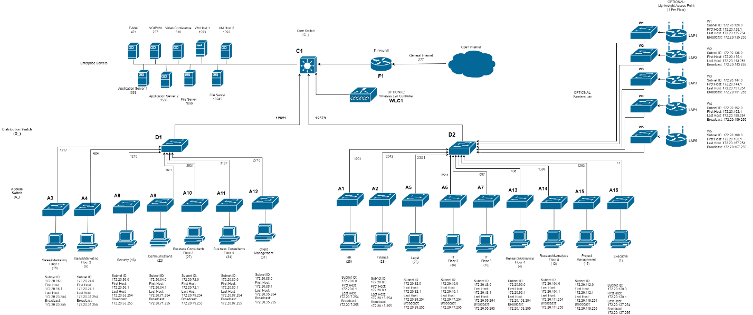

**Note:** All proposed access-level switches are numbered in physical ascending order, therefore A1 is on the first floor, whereas A16 is on the fifth floor.

Based on employee count we have calculated that your business will require a total maximum bandwidth of 25.2 Gb/s.

As such, we made the decision to logically divide your network into 2 “trunks”. Each trunk has an approximate bandwidth uplink of 12.6 Gb/s.

Subnetting recommendations have been applied to each diagram such that every Access switch will have its own independent subnet id, as well as a range of available hosts. Subnets have been set in order to maximize the number of available host nodes per subnet and are further detailed in Appendix C: Subnetting.

**C1 (Core)**

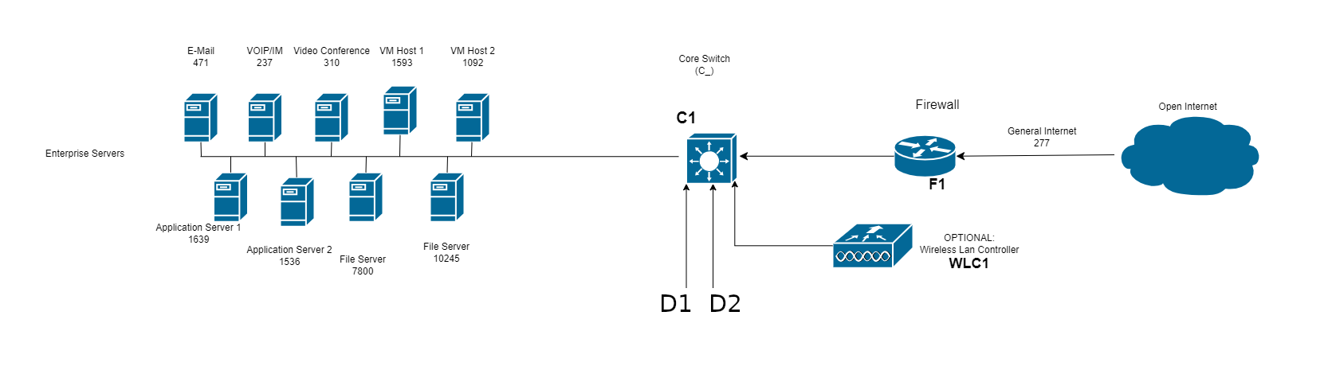

In our design, your Rogers Business Internet Connection is fed to a FirePOWER 3140 firewall which will protect your network from the open internet. From there, “C1” serves to represent your primary core switch. This Catalyst 9300X is where your enterprise servers will directly connect to the network and where a Catalyst 9800 WLC will be connected to control an array of access points we will detail later in this document. Both distribution tier switches we have provided will connect to C1 at this level.

**D1 (Distribution 1)**

Depicted in this diagram is a switch we refer to as “D1”, another Catalyst 9300X which will serve as the first in a set of 2 distribution switches for your network. 7 access level switches are connected to D1 and these switches will provide direct connections for your employees. Notably, no horizontal branches are routed vertically anywhere in this configuration and each of the depicted departments are isolated on independent access-level switches which provides added network security and TIA/EIA compliance.

The total uplink bandwidth from the distribution switch will be approximately 12621Mb/s.

**D2 (Distribution 2)**

Like C1 and D1, D2 is also a Catalyst 9300X and will serve a connection to 9 more access level switches. As was the case with D1, each department is isolated on their own access switch for network security and TIA/EIA compliance. Notably, the “D2” trunk of our topology includes another 5 switches which serve a connection to a set of access points we have included in this design. See sector “W” for details.

The approximate total bandwidth going from D2 up to the core layer will be 12579 Mb/s.

**W (Wireless Foundation)**

Pending a formal site survey, our design provides 5x CBS350-8FP-E-2G switches and 5x C9120AXI-EWC-A Access Points which will each serve an individual floor of your campus and is provided its uplink by the “D2” trunk.

This configuration, and the aforementioned site-survey will be detailed in the Wireless component of this report.

**Proposed Physical Network Layout**

This design makes use of a first-floor entrance facility (EF) which houses the demarcation point provided by Rogers. This demarcation point will be extended through conduit directly up to the second floor which will provide a short and efficient channel between the EF and the primary equipment room (ER).

Although the EF occupies some portion of the first-floor finance office and the ER occupies the majority of the second floor East IT office, we have calculated the space the EF and ER will occupy and are confident the space will NOT displace any employees as you currently plan to have them situated. Specifically, the ER will occupy 144m2 which will leave 115m2 for the staff that will work there. Given the 10 employees and an average cubicle size of around ~6m2 this will leave roughly 55m2 for walking and airflow which we anticipate will be more than sufficient. The ER itself will contain the primary core switch (C1), firewall (F1), WLC, and all of your enterprise servers and virtual hosts.

From the ER, a backbone of multimode fibre is provided to each telecommunication room (TR) on the second floor. These TRs each house a distribution switch (respectively D1 and D2) and several access level switches. Housing D1 and D2 in these closets (TR2A/TR2B) minimizes the overall length of fibre connections; providing a cheaper, and more secure solution compared to running fibre horizontally on the second floor.

From these distribution switches, a vertical backbone of multimode fibre provides direct connection to access level switches within the aligned TRs on each floor. These access level switches will serve connections to all 311 employees and your president via CAT-6 cable. All horizontal runs from TR to workstation are less than 90m in total and maintain TIA/EIA compliance. For clarity, this cabling is omitted from the following diagrams but are detailed in the Cabling section of this document.

All devices are named and mapped on a floor by floor basis as per the attached table, and are detailed in the Hardware section of this document.

The following diagrams outline the proposed physical network for Apollo’s 5 story campus.   
A legend has been provided on each page for convenience and clarity.

**First Floor**

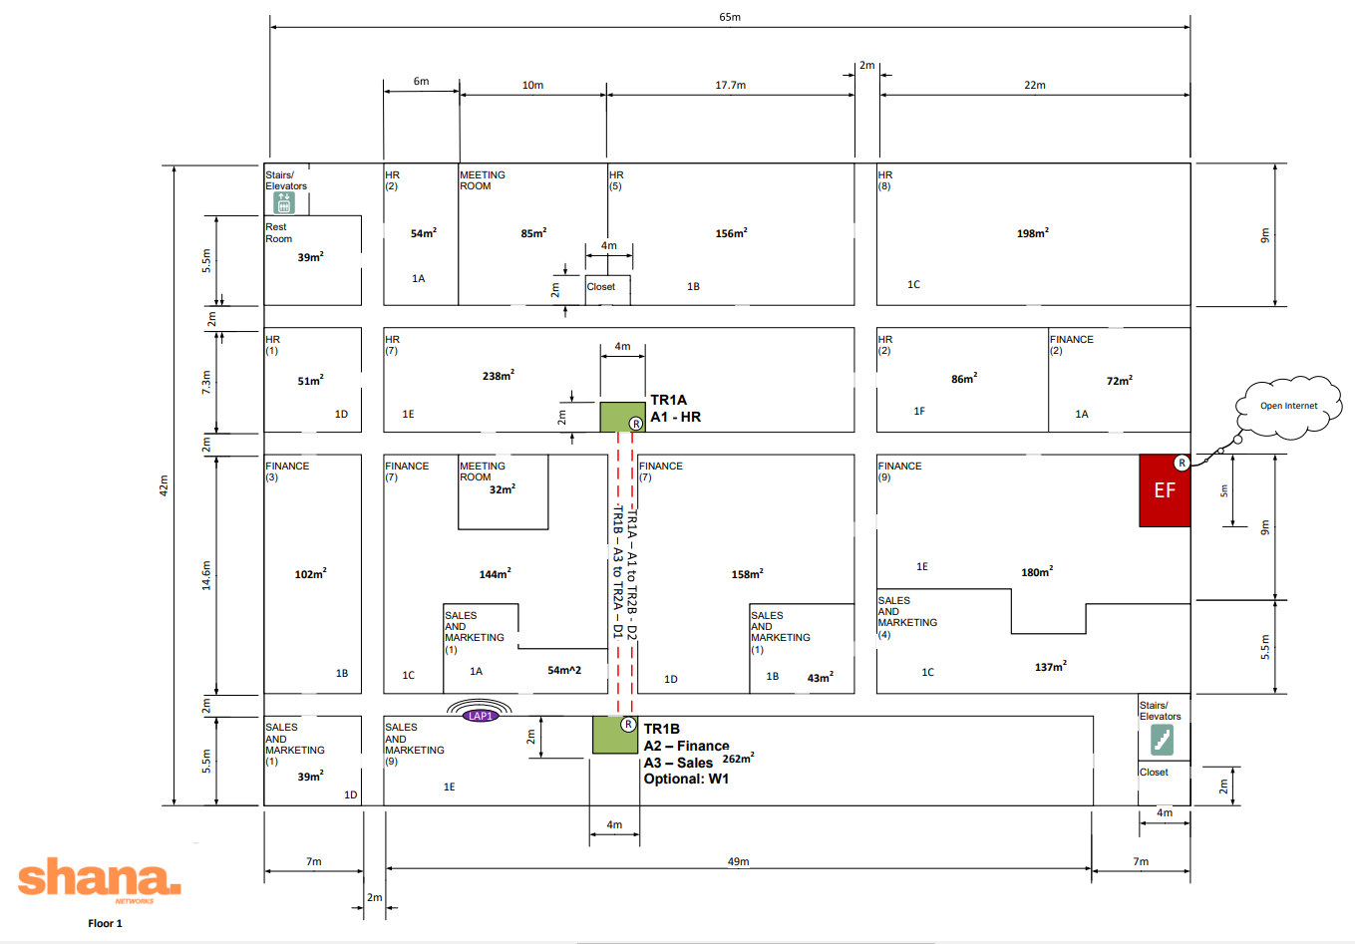

**HR - 25 employees:**  
A1 - CBS350-48FP-4X

**Finance - 28 Employees:**  
A2 - CBS350-48FP-4X

**Sales (Floor 1) - 16 Employees:**  
A3 - CBS350-24P-4X

**Wireless (optional)**   
W1 - CBS350-8FP-E-2G

**Notes:**In all floor plans the North wiring closet is labelled with the suffix “A”, and the South wiring closet is labelled with the suffix “B”. The number signifies which floor the wiring closet is located on. (Ex. TR4B = South TR, 4th floor, TR1A = North TR, 1st floor).

All access switches have been placed in the closets which are physically closest to their respective departments.

**Second Floor**

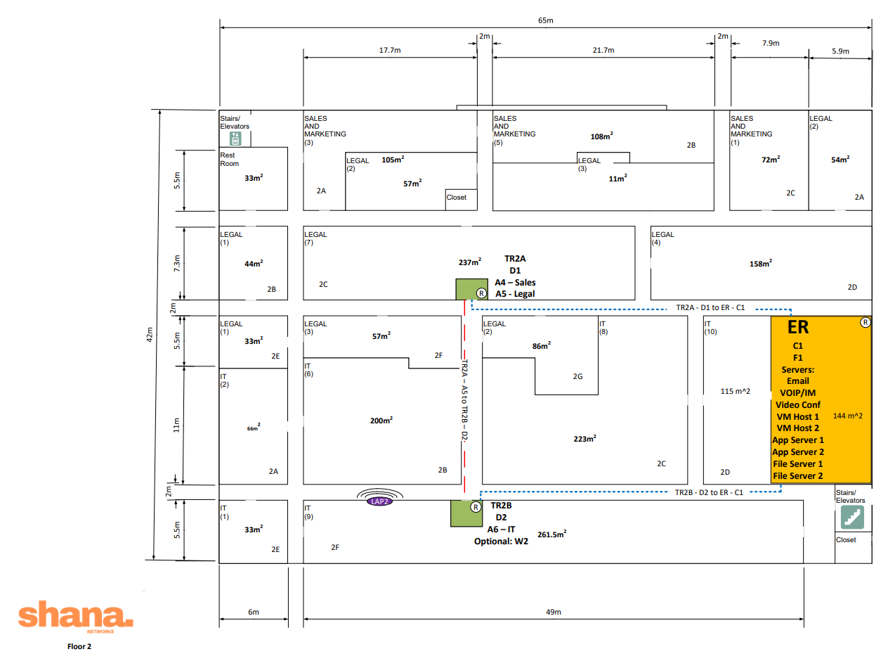

**Sales (Floor 2) - 9 Employees:**  
A4 - CBS350-24P-4X

**Legal - 25 Employees:**  
A5 - CBS350-48FP-4X

**IT (Floor 2) - 36 Employees:**  
A6 - CBS350-48FP-4X

**Wireless (optional)**  
W2 - CBS350-8FP-E-2G

**Notes:**Authorization to locate D1 and D2 within TR2A and TR2B (respectively) was provided by the client on December 2nd. This design significantly reduces the total length of required multi-mode fibre cabling (approximately 300m), dramatically lowers capital overhead, and provides significantly more security and physical protection for the network backbone.

**Third Floor**

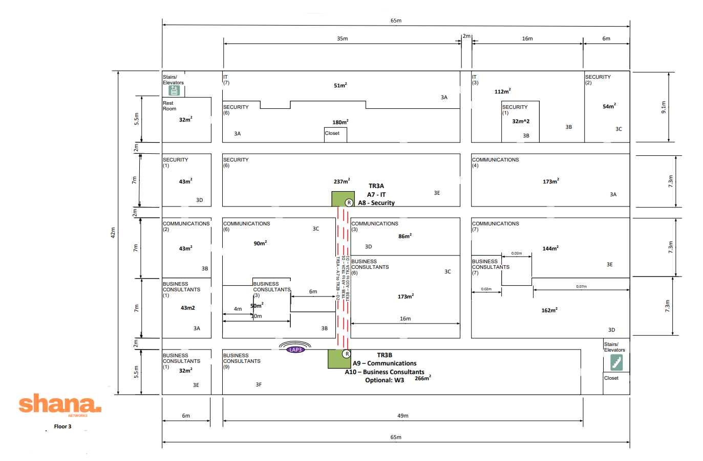

**IT (Floor 3) - 10 Employees:**   
A7 - CBS350-24P-4X

**Security - 16 Employees:**   
A8 - CBS350-24P-4X

**Communications - 22 Employees:**  
A9 - CBS350-24P-4X

**Business Consultants (Floor 3) -  
27 Employees:**  
A10 - CBS350-48FP-4X

**Wireless (Optional)**  
W3 - CBS350-8FP-E-2G

**Notes:**The third floor has a simple configuration, with two TRs, 4 access-level switches and an optional LAP and wireless access switch (see Wireless).

**Fourth Floor**

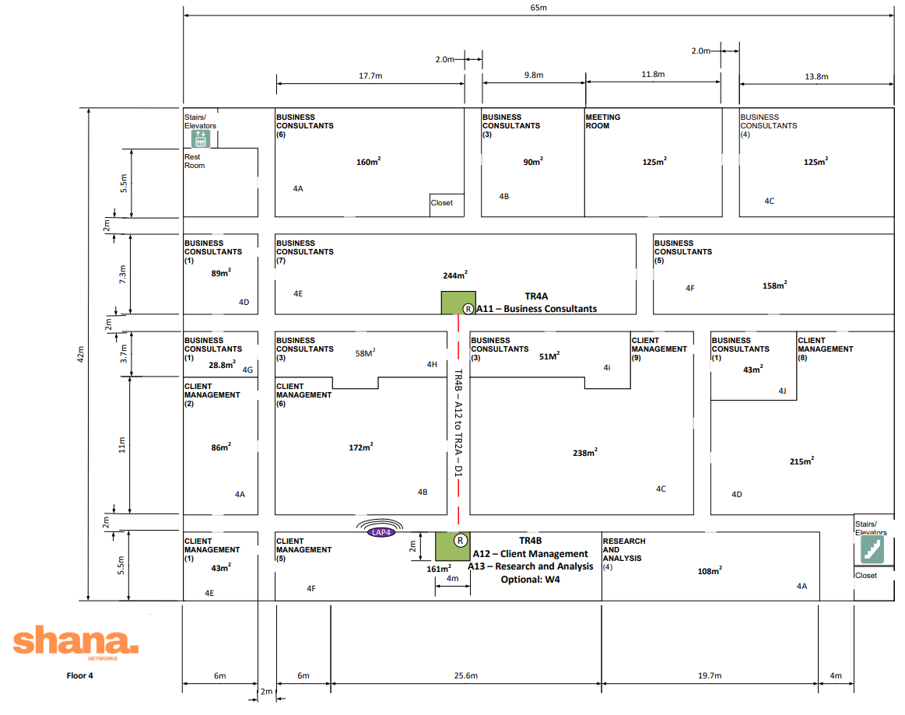

**Business Consultants (Floor 4) -  
 34 Employees:**  
A11 - CBS350-48FP-4X

**Client Management - 31 Employees:**A12 - CBS350-48FP-4X

**Research (Floor 4) - 4 Employees:**  
A13 - CBS350-24P-4X

**Wireless (Optional)**  
W4 - CBS350-8FP-E-2G

**Notes:**Similarly, Floor 4’s simple configuration contains 2 TRs, and 3 Access-level switches as well as an optional LAP and access switch for wireless configuration (see Wireless).

**Fifth Floor**

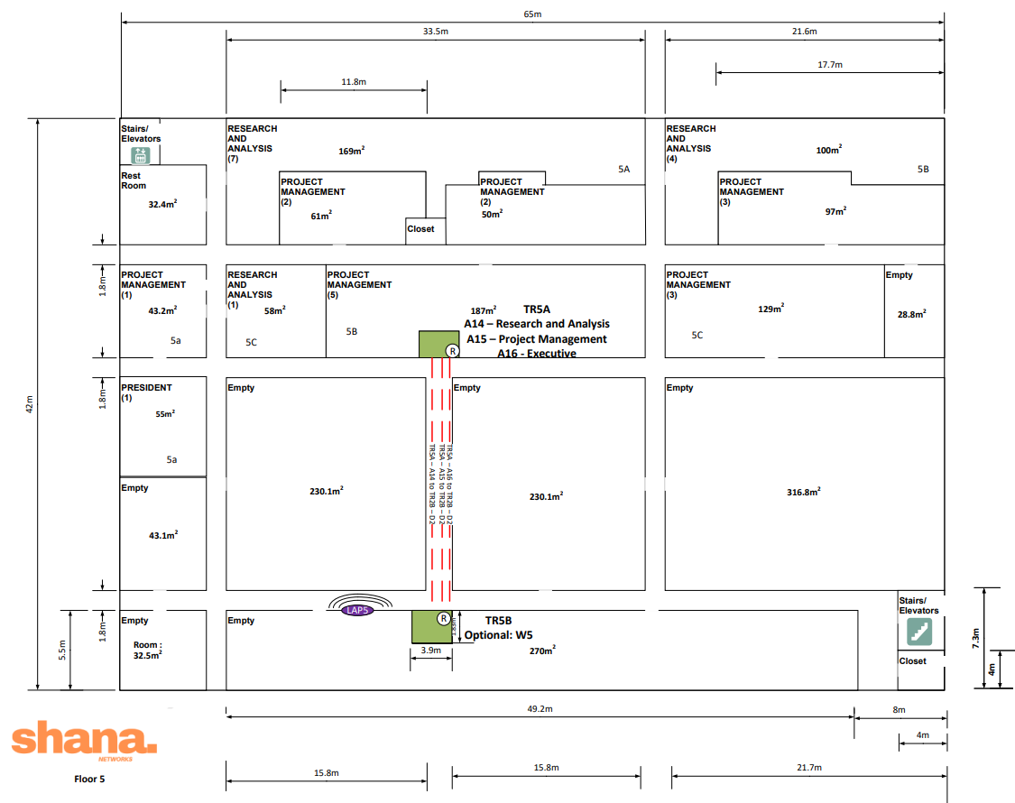

**Research (Floor 5) - 12 Employees:**  
A14 - CBS350-24P-4X

**Project Management - 16 Employees:**A15 - CBS350-24P-4X

**Executive**  
A16 - CBS350-24P-4X

**Wireless (Optional)**   
W5 - CBS350-8FP-E-2G

**Notes:**Finally, the fifth floor contains 3 access switches, all located in the north wiring closet (TR5A). The south TR (TR5B) may optionally contain the access switch which will be used for future LAPs and has been purposely left vacant for the expansion we expect in this wing of the campus.

**Cabling**

Our plan is to install a demarcation point extension from the first floor entrance facility to our equipment room via plenum rated multi-mode fibre cable directly into our firewall. From here, the same plenum fibre connects to our core switch in our equipment room where 2 fibre trunks span to our distribution switches separately located in telecommunication rooms TR2A and TR2B. These distribution switches connect with fibre to each of our access switches vertically through our TRs and horizontally to the appropriate switch according to how our network bandwidth is load balanced.

Horizontal cabling is organized with cable trays attached to existing building infrastructure with threaded rods, allowing plenty of room within plenum space for cable expansion and providing easy cable management. Our access switches use Category 6 plenum rated cables to reach client work areas and access jacks within each office, all of which comply with TIA/EIA 568 standards. These jacks connect to Category 6 work area cables for each office, providing all employees with a reliable, fast network connection. Additionally, plenum rated fibre cables provide network redundancy between telecommunication rooms on each floor, and patch panels within network device racks allow fast accessibility to every port on every switch.

**Total Cable Lengths**

|  |  |  |  |
| --- | --- | --- | --- |
| Placement | Type | Total Length | Cost Estimate |
| Work Area | Category 6 | 1691 meters | ~$4,633.34 |
| Horizontal | Category 6 | 11792 meters | ~$124,363.35 |
| Backbone | Multi-mode Fibre | 345 meters | ~$3,057.60 |
| TR Patch Cables | Cat6/Fibre | 163 meters | ~$1,040.45 |

**Work Area Cable**

|  |  |  |  |
| --- | --- | --- | --- |
| Cable | Description | Amount | Image |
| RJ45 Cat6 UTP Ultra-Thin Patch Cable - Premium Fluke® Patch Cable Certified - CMR Riser Rated | Category 6 cables of various lengths per office provide client node access within each office | 311 cables between 1-13 meters:  ~$2.74/meter |  |

**Note**: All measurements are in **METERS**, please disregard the following table headers showing feet.

**Floor 1 - Work Area (Calculations in Meters)**

**Floor 2 - Work Area (Calculations in Meters)**

**Floor 3 - Work Area (Calculations in Meters)**

**Floor 4 - Work Area (Calculations in Meters)**

**Floor 5 - Work Area (Calculations in Meters)**

**Horizontal Cabling**

|  |  |  |  |
| --- | --- | --- | --- |
| Cable | Description | Amount | Image |
| 304.8 meters 4 Pair CAT6 Solid U/UTP 550Mhz 23AWG CMP Plenum Bulk Cable | Plenum rated Category 6 cabling is bought in bulk to cover the 11697 meters required for the entire company | 39 boxes @ $362.50/each |  |
| Middle Atlantic 6’ Long 5/8” Threaded Rod | Threaded rods connect our cable trays to our ceiling cable runs within hallways to our work areas | ~400 @ $48.99/each |  |
| Tripp Lite Rack Enclosure Cabinet 10ft Roof Cable Manager Ladder 10' - rack roof mount cable manager ladder | Cable trays provide cable organization and easy management within the office’s hallways and infrastructure | ~400 @ $225/each |  |
| OM4 Multimode 50 Micron Indoor (Corning ClearCurve) - OFNP Plenum Fibre Bulk Cable - 12-Strand | Plenum rated fibre cable connects between TR rooms on each floor providing redundant connections between both distribution trunks | 95 meters @ $6.63/meter |  |

**Floor 1 - Horizontal (Calculations in Meters)**

**Floor 2 - Horizontal (Calculations in Meters)**

**Floor 3 - Horizontal (Calculations in Meters)**

**Floor 3/4 - Horizontal (Calculations in Meters)**

**Floor 4/5 - Horizontal (Calculations in Meters)**

**Note:** An additional 95 meters of multi-mode fibre can connect between TR1-5A and TR1-5B on their respective floors providing redundancy between distribution branches.

**Backbone Cabling**

|  |  |  |  |
| --- | --- | --- | --- |
| Cable | Description | Amount | Image |
| OM4 Multimode 50 Micron Indoor (Corning ClearCurve) - OFNP Plenum Fibre Bulk Cable - 24-Strand | Plenum rated fibre cable bought in bulk to connect from Demarcation to F1 to C1 with D1 and D2 | 74 meters @ $12.73/meter |  |
| OM4 Multimode 50 Micron Indoor (Corning ClearCurve) - OFNP Plenum Fibre Bulk Cable - 12-Strand | Plenum rated fibre cable bought in bulk to connect each access switch with its distribution switch | 271 meters @ $6.63/meter |  |
| 3m LC/PC 12-Fibre OM4 Multimode Simplex 50 micron - 900um Pigtail - Color Coded | Spliced pigtails allow our fibre cable to connect with our fibre patch panels and backbone switches | 7 @ $45.55/each |  |

**Note:** Distribution switches located in TR2A and TR2B to save on fibre cabling costs and increase security

**Telecommunication Rooms Patch Cabling**

|  |  |  |  |
| --- | --- | --- | --- |
| Cable | Description | Amount | Image |
| RJ45 Cat6 UTP Ultra-Thin Patch Cable - Premium Fluke® Patch Cable Certified - CMR Riser Rated | Category 6 cables for connecting switches with patch panels within our racks – 6 inches | 156 @ $2.10/each |  |
| RJ45 Cat6 UTP Ultra-Thin Patch Cable - Premium Fluke® Patch Cable Certified - CMR Riser Rated | Category 6 cables for connecting switches with patch panels within our racks – 1 foot | 156 @ $2.21/each |  |
| OM4 Multimode Duplex LC/LC 50 Micron - Fibre Optic Patch Cable - 2mm Jacket - LSZH/OFNR - 0.5m | Fibre cables for SFP+ connects between switches | 46 @ $8.05/each |  |

**Hardware**

Every tier of this network design makes use of high-end Cisco switches. Each device was carefully selected based on available features, and specific models and sizes were selected to support the growth Apollo Business Consulting expects to see over the next several years.

**Firewall**

**Cisco FirePOWER 3140 Next Gen Firewall (FPR3140-NGFW-K9) (1x)**

Boasting a 48 Gbit throughput, this firewall ensures that security will never be a bottleneck on your system. The model implemented in our design provides an 8-port interface to allow for all types of physical configurations as needed. We understand Apollo Business Consulting deals regularly with sensitive company and client information and we believe this firewall will provide Apollo and its clientele with the assurance that their data will be protected at all times.

**Core and Distribution**

**Cisco Catalyst 9300X – 24 Port (C9300X2-24Y) (3x)**

This 24-port stackable switch comes from a line of Cisco products that are built for enterprise grade security, mobility, and scalability. It offers flexible modular uplinks of either 100, 40, 24, 10, or 1 Gbit and all provided ports are SFP28 which allow for fibre or CAT-6 expansion in either 1, 10, or 25 Gbit configurations.

This design will make use of a 24 Gbit uplink from C1 to D1 and D2 which will provide nearly twice the uplink we have calculated each logical trunk will require (~12.6 Gbit/s).

Should future expansion require it, this line of switches offers full backward compatibility, and their modular design allows for higher uplink and throughput speeds to ensure bandwidth is never an issue even on even the largest networks. The 9300X is a rack mountable managed switch, that provides a myriad of useful features like integrated routing (11 protocols), ACL support, Cisco’s StackWise technology, Full duplex mode, Layer 3 VPN support, Private VLAN functionality, Virtual Extensible LAN, VLAN double tagging and much more. Should your IT department choose to implement a VLAN to support your growth, rest assured your core and distribution switches are prepared to manage it.

**Access Switches**

**Cisco Business 350 (CBS350-48FP-4X) x8, (CBS350-24FP-4X) x8, (CBS350-8FP-E-2G) x5**

Our access-level design is provided by Cisco’s Business 350 series of switches. Each department has been provided either a 24 or 48-port switch depending on the number of employees that need to be served on each floor. Departments that exist on separate floors have been provided with multiple separate switches respectively.

Although admittedly costs could have been cut for smaller departments by making use of smaller port count switches from this line of products, our design opted to lean in in the direction of higher port counts to support the inevitable growth of Apollo Business Consulting. All ports on these switches are POE+ and will be capable of supporting the variety of POE devices like VOIP phones we expect your employees will be making use of.

These switches are also managed and come packed with additional features like dynamic Layer 3 policy-based routing, DHCP services, ACL functionality, and of course VLAN support. The Business 350 switches in our design all serve Gigabit Ethernet on each port with 4x 10 Gbit SFP+ uplinks. Our calculations have determined a department maximum required bandwidth of ~3.3Gbit/s which these switches are more than capable of providing.

In addition to the 16 access level switches provided from this line of products, we have included 5 additional Business 350 switches (CBS350-8FP-E-2G) to support an array of access points (see Wireless).

**Wireless**

**WLC**

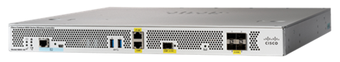

**Cisco Catalyst 9800 Wireless Controller (C9800-40-K9)**

This top-of-the-line Cisco product will provide your network with a best-in-class wireless experience by way of this robust, and secure wireless controller. The Catalyst 9800-40 provides seamless software updates and is recommended for midsize or large enterprises as it provides the capability of controlling up to 2000 wireless access points and 32,000 clients.

**Access Points**

**Cisco Catalyst 9120AXI Access Point (C9120AXI-EWC-A) x5**

Our design includes 5 resilient and secure access points from Cisco’s 9120 line of APs. Perfect for networks of all sizes, this product is designed to support the latest innovations in the growing realm of the Internet of Things (IoT) and supports Wi-Fi 6 (IEEE 802.11ax), an emerging standard in wireless technology.

Although Apollo Business Consulting did require wireless functionality for this network, the team at SHANA typically bundles an initial set of access points (~1 per floor) for configuration and testing. Additional details on our philosophy and process are provided below.

**Optional: Wireless Site Survey**

Given the nature of your new 5-floor campus, planning the installation of a wireless network will require a thorough Wireless Site Survey. As mentioned previously, SHANA Networks provides an initial bundle of access points in all of our designs to facilitate the testing that this survey will require.

***Please note this survey is highly recommended but entirely optional.***

All wireless site surveys are different and standard office layouts can differ wildly in their physical construction and in the various sources of radio interference that may be situationally present.

The goal of a site survey will be to ensure seamless, strong signal in all work-areas, and constant reliable connection to network resources; all at reasonable throughputs. Although we’re confident the network we have designed is more than capable of supporting your enterprise, there is no doubt that the convenience of a wireless configuration will support Apollo’s commitment to fostering the environment of innovation and collaboration that will stoke the growth you expect over the coming years.

This survey will include an RF spectrum analysis which will identify any points of interference and account for them in our calculations, a coverage analysis to determine optimal AP locations and mitigate the possibility dead-zones, and finally a thorough set of documentation which we will provide to Apollo that will serve as a set of recommendations and as a guide should any future maintenance or installation be required.

For the purposes of this proposal, we would like to recognize that 5 access points are a lightweight solution to a problem you do not yet have. However, if your staff determines there is value in expanding this initial configuration, the team at SHANA Networks will be more than happy to execute this survey and provide you with a fast and seamless wireless network.

**Cost Estimates**

Given the growth Apollo Business Consulting expects over the coming years, this design was conceptualized and planned at every stage with scalability in mind. We have opted to provide hardware of the highest grade with the intention that your organization can grow into it and scale with you. Please note that we are happy to make adjustments to this configuration should your company decide that this level of scalability is unnecessary. This may reduce the total cost of this estimate significantly. However, given our understanding of your enterprise, we recommend this configuration be adopted as currently configured.

This design will implement a substantial amount of horizontal cabling and will require secure and effective cable management systems. This estimate includes cable trays and threaded rods within the plenum space of office hallways, and our solution presents the best option for long-term company expansion. Lower cost cable-management alternatives are available and may be implemented according to the aesthetic appeals of the company as well as physical limitations of the existing physical infrastructure. Rest assured, our cable management system will skillfully adapt with the overall design of the office.

Additionally, more redundant connections between telecommunications rooms on each floor along with extra multi-mode fibre connections between C1, D1, and D2 could provide more reliability between switches for substantially more cost if the company wishes to have maximum network resiliency.

Given these insights, our current reported estimate amounts to the following:

|  |  |
| --- | --- |
| Total acquisition cost:  **$ 531,639.35** | Yearly upkeep:  **$ 34,992.57** |

**Note:** Additional insight into our pricing logic, specifically in terms of annual upkeep is provided in Appendix D: Cisco Pricing.

**Conclusion**

We admire your commitment to future-forward innovation and collaboration and know running such an organization requires a powerful and robust network. We hope the folks at Apollo Business Consulting will find that our solutions provide your enterprise with a network that will propel your operations into the future.

At every opportunity we have made the effort to adhere to TIA/EIA compliance all while ensuring our physical and logical designs meet your own corporate standards. The team at SHANA believes in this network and are confident this design is one your company can reliably lean on while you grow into your new 5 floor campus.

The feedback you have provided us through this process has been invaluable and we look forward to producing network solutions for your impressive workforce as your needs change and develop over the coming years.

Finally, please do not hesitate to reach out should you or any relevant parties from your organization wish to further tune this design to fit your expectations.

On behalf of the entire SHANA Networks team:

*Thank you once again for the opportunity to develop and present this network proposal.*

Antonio Giacchetti  
Adam Lo Giudice  
Henry Oyewole  
Scott Richards  
Neil Power

**Appendices**

**Appendix A: TIA/EIA Compliance**

Our design follows all TIA/EIA network compliance, some examples include:

* Twisted pair cabling will all use TIA/EIA T568B colour standards
* Cable trays have been approved for backbone cabling
* All MMF fibre wiring is less than 2 Km long
* Horizontal cabling is terminated into a patch panel in the TR
* All horizontal wiring is below the 90 m limit for TO to TR connectivity
* Backbone cabling follows a hierarchal logical star topology
  + including TRs, EF and servers connecting to the ER

**Appendix B: Current Floorplans**

The unoccupied offices are currently configured as follows:

**Floor 1**

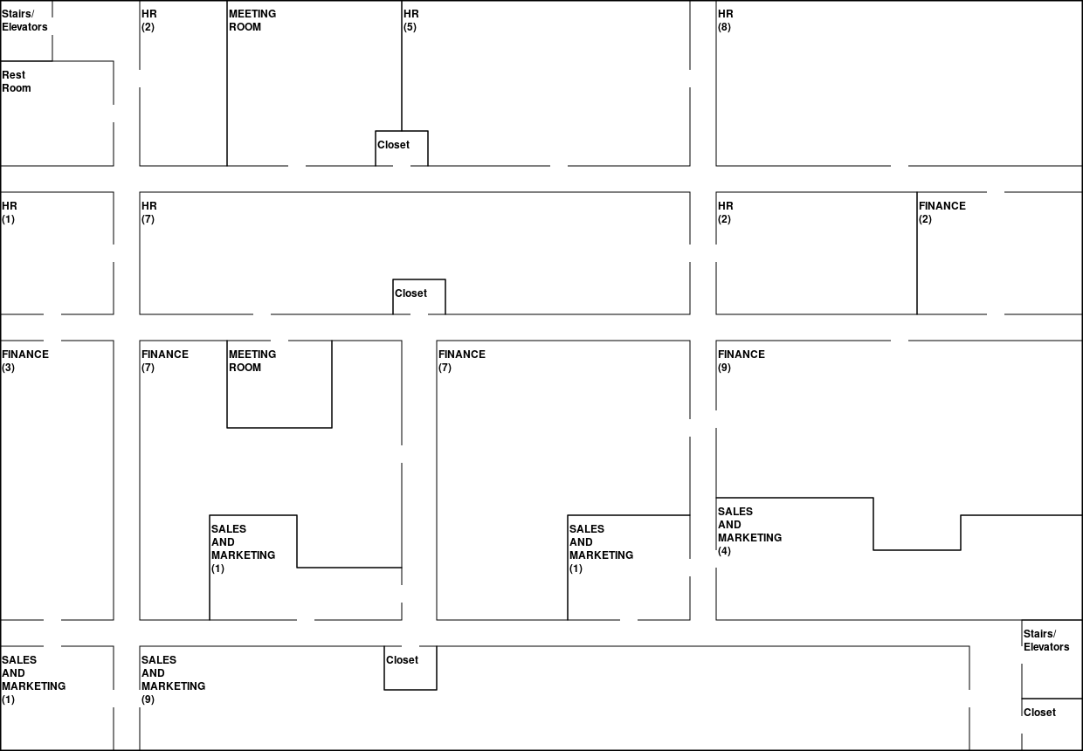

**Floor 2**

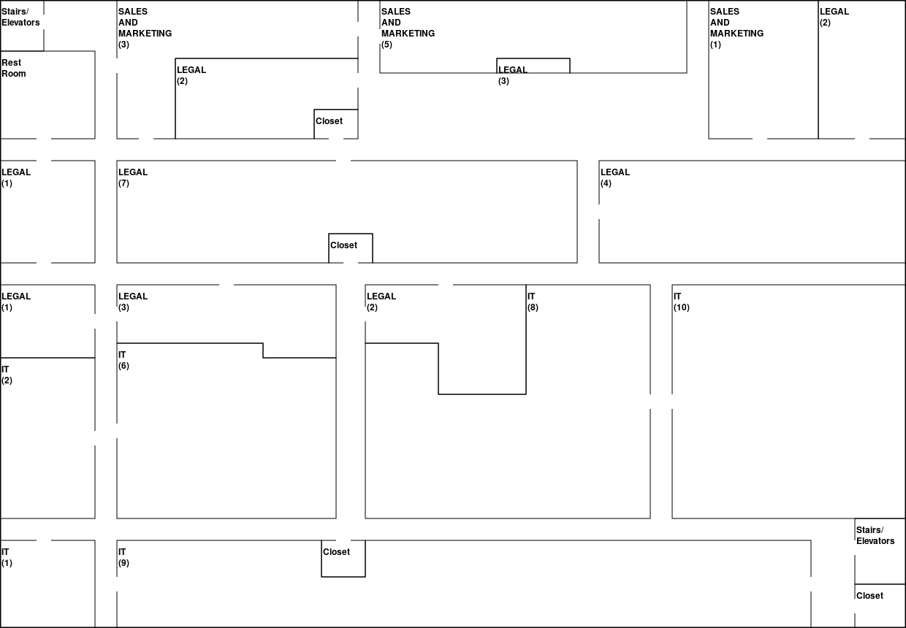

**Floor 3**

**Floor 4**

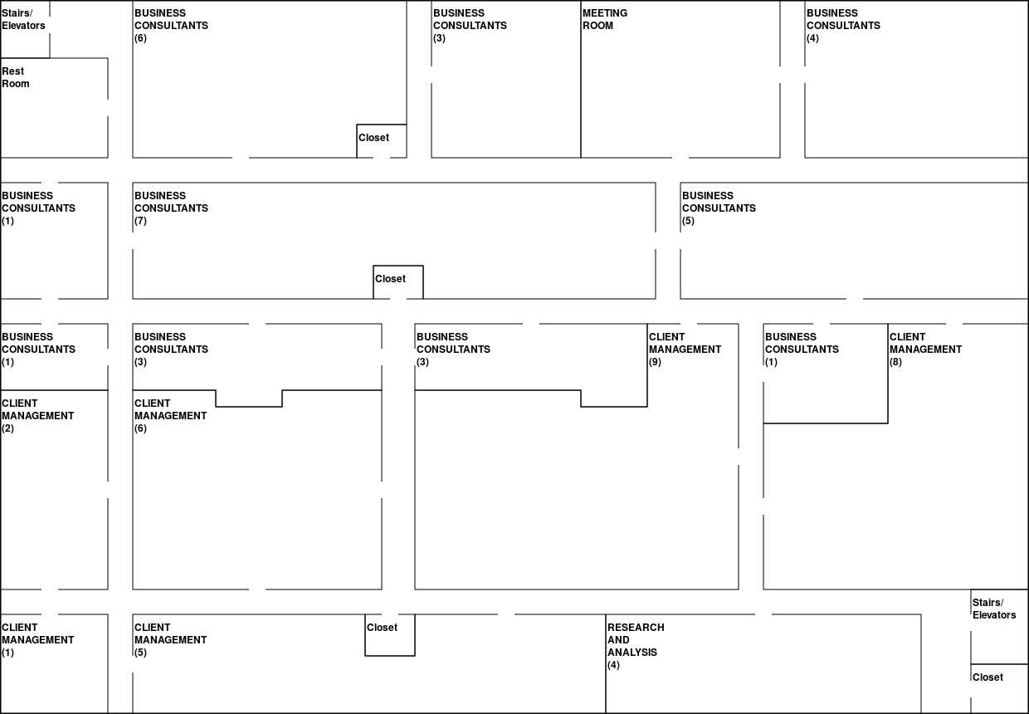

**Floor 5**

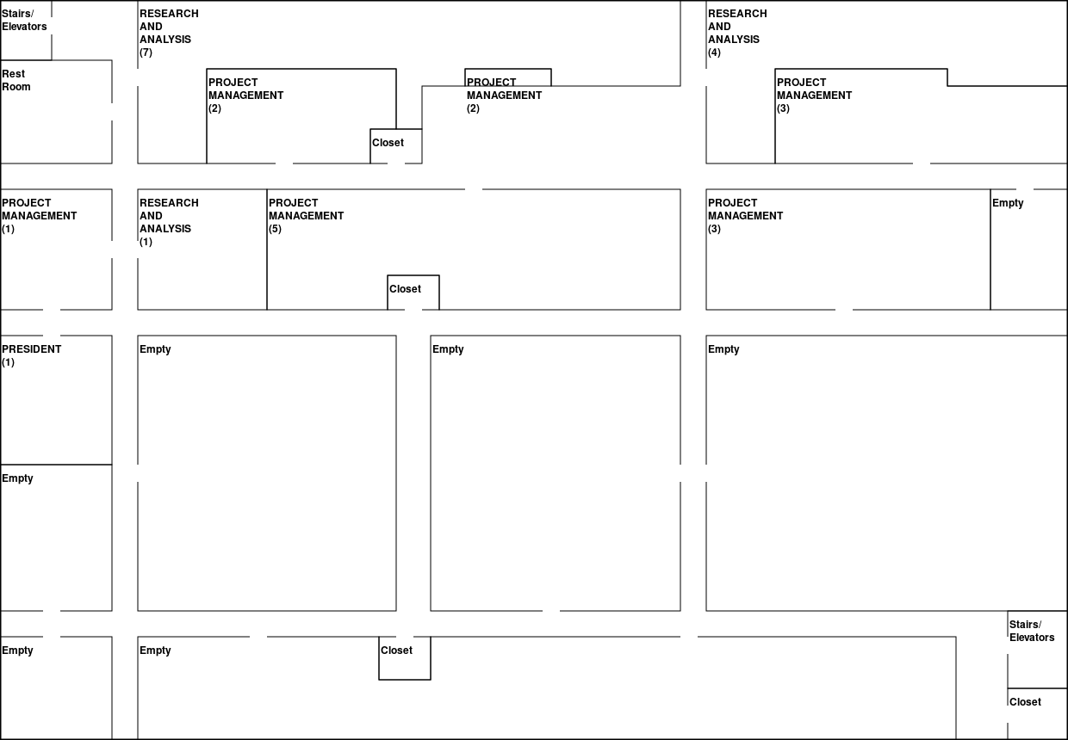

**Appendix C: Subnetting**

**Suggested subnet configuration:**

Private Class B Ip Address: 172.20.0.0  
Default Subnet Mask: 255.255.0.0   
Subnet Mask: 255.255.248.0 /21  
Need 21 Subnets, Need 5 Subnet Bits

172.20.[00000]000.00000000  
Each subnet has 2046 Hosts Available

**Primary Access Level Subnets:  
Note:** Subnets assigned in physical ascending order.

|  |  |  |  |  |  |
| --- | --- | --- | --- | --- | --- |
| **Switch** | **Department** | **Subnet ID** | **First Host** | **Last Host** | **Broadcast** |
| A1 | HR | 172.20.0.0 | 172.20.0.1 | 172.20.7.254 | 172.20.7.255 |
| A2 | Finance | 172.20.8.0 | 172.20.8.1 | 172.20.15.254 | 172.20.15.255 |
| A3 | Sales & Marketing (Floor 1) | 172.20.16.0 | 172.20.16.1 | 172.20.23.254 | 172.20.23.255 |
| A4 | Sales & Marketing (Floor 2) | 172.20.24.0 | 172.20.24.1 | 172.20.31.254 | 172.20.31.255 |
| A5 | Legal | 172.20.32.0 | 172.20.32.1 | 172.20.39.254 | 172.20.39.255 |
| A6 | IT (Floor 2) | 172.20.40.0 | 172.20.40.1 | 172.20.47.254 | 172.20.47.255 |
| A7 | IT (Floor 3) | 172.20.48.0 | 172.20.48.1 | 172.20.55.254 | 172.20.55.255 |
| A8 | Security | 172.20.56.0 | 172.20.56.1 | 172.20.63.254 | 172.20.63.255 |
| A9 | Communications | 172.20.64.0 | 172.20.64.1 | 172.20.71.254 | 172.20.71.255 |
| A10 | Business consultants (Floor 3) | 172.20.72.0 | 172.20.72.1 | 172.20.79.254 | 172.20.79.255 |
| A11 | Business Consultants (Floor 4) | 172.20.80.0 | 172.20.80.1 | 172.20.87.254 | 172.20.87.255 |
| A12 | Client Management | 172.20.88.0 | 172.20.88.1 | 172.20.95.254 | 172.20.95.255 |
| A13 | Research & Analysis (Floor 4) | 172.20.96.0 | 172.20.96.1 | 172.20.103.254 | 172.20.103.255 |
| A14 | Research & Analysis (Floor 5) | 172.20.104.0 | 172.20.104.1 | 172.20.111.254 | 172.20.111.255 |
| A15 | Project Management | 172.20.112.0 | 172.20.112.1 | 172.20.119.254 | 172.20.119.255 |
| A16 | Executive | 172.20.120.0 | 172.20.120.1 | 172.20.127.254 | 172.20.127.255 |

**Optional Wireless Subnets**

|  |  |  |  |  |  |
| --- | --- | --- | --- | --- | --- |
| **Switch** | **Floor** | **Subnet ID** | **First Host** | **Last Host** | **Broadcast** |
| W1 | 1 | 172.20.128.0 | 172.20.128.1 | 172.20.135.254 | 172.20.135.255 |
| W2 | 2 | 172.20.136.0 | 172.20.136.1 | 172.20.143.254 | 172.20.143.255 |
| W3 | 3 | 172.20.144.0 | 172.20.144.1 | 172.20.151.254 | 172.20.151.255 |
| W4 | 4 | 172.20.152.0 | 172.20.152.1 | 172.20.159.254 | 172.20.159.255 |
| W5 | 5 | 172.20.160.0 | 172.20.160.1 | 172.20.167.254 | 172.20.167.255 |

**Appendix D: Cisco Pricing**

All prices presented in our cost breakdown were calculated using available tools provided by the reseller CDW. CDW provides various levels of extended service agreements which provide 8 hours of hardware replacement per day, 5 days a week, with next business day delivery (8x5 NBD).

These packages, and their prices can vary greatly depending on several factors and unfortunately these rates were not explicitly available for our access level switches.

Given this case, we opted to recommend an overall average allocation of approximately ~10% the original hardware cost to cover these fees.

We recognise this estimation is fairly vague so we spoke briefly with a Cisco Sales Specialist who provided some insight into the additional features these fees cover.

Our understanding is that with the purchase of Cisco hardware, a client will typically need to also purchase software licenses for network management features like Cisco Digital Network Architecture (DNA) as well as a subscription to Cisco’s SmartNet support service which provides access to technical support, software updates, and other maintenance features for the lifespan of each device.